C. elegans Synchronizer System
CES-5000
Protocol for synchronization of L1 nematodes

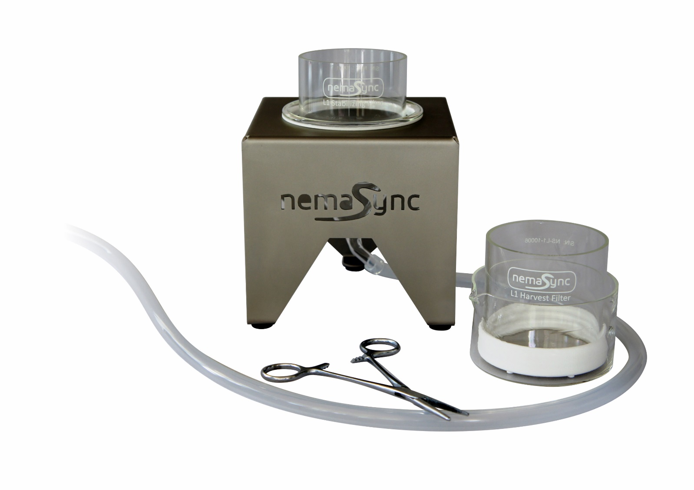
Warning:
- Make sure to protect the filters when not in use by placing a 90mm petri dish cap on each side.
- When working with pipettes, be careful not to puncture the filters.
- Before use, please read the general instructions.
Preparation:
- Sterilize the filters, funnel, crystallizing dish, etc, with 70% ethanol and rinse once with sterile, demi water or S Medium.
- For optimal yield and synchronization the majority of the C. elegans culture should consists of gravid adults and eggs.
Protocol:
A: Stabilizing of Gravid Population
- Place funnel in holder.
- Attach tubing to funnel and place end of tubing in a (waste) container / receiver.
- Place the “Stabilization filter” in the funnel.
- Select a population of worms (from NGM plate or liquid culture) with a high number of gravid adults. Ensure the population is well fed for optimal L1 yield.
- Transfer the worms to “Stabilization Filter” with glass pipet.
- Rinse the worms in the stabilization filter with sterile water or S Medium till most debris is removed.
- Close/pinch the silicone waste tube using a Hemostat clamp or similar device.
- Fill the stabilization filter and funnel with sterile S Medium a few (~5mm) millimeters above the filter surface.
- Let the worms sediment for 5 up to 10 minutes.
- Keep the Hemostat clamp closed and continue with Harvest steps below:
B1: Harvest L1’s in liquid
- Add ~10ml S Medium into a clean glass dish.
- Slightly tilt and place the “Harvest filter” in the dish with clean buffer. Make sure there is no air trapped under the filter! Make sure there is a few millimeters of S Medium above the filter surface.
- Transfer the content of the “Stabilizing filter” in to the “Harvest filter” with a glass pipet. Make sure the entire bottom and top of the filter is covered with buffer in order to let the L1 nematodes through.
- Cover the top of the “Harvest filter” with a petri dish to prevent contamination and evaporation.
- Leave the “Harvest filter” in the dish for 15 minutes up to 12 hours / overnight*, depending on the amount and level of synchronization required. L1’s will hatch and pass through the filter.
- Slowly remove “Harvest filter” and set aside. At this point, the “Harvest filter’ could again be placed in a clean glass dish with buffer for a second harvest.
- Transfer contents of dish to conical tube(s).
- Use centrifuge to spin down L1’s (~5 minutes at 1200-2000g)
- Transfer worm pellet to seeded NGM plate or liquid culture.
* If large volumes are needed and food arrest is to be avoided; after approximately 7-8 hours (the time for newly laid egg’s to start hatching), the L1’s harvested till that point are to be disposed and a new short (1 – 2 hours) harvest cycle to be (re)started. See also remark about adding Serotonin at the Harvest step (11) of the protocol and not using M9 as this inhibits egg-laying.
Cleaning / descaling the filters:
1a Soak filters in a 0.5-1 M NaOH for 30 minutes up to an 1 hour.
1b Alternative: use a small 2 liter 40 Hz ultrasonic cleaner, filled with 0.5-1 M NaOH, and clean the filters for approximately 5 minutes. The ultrasonic cleaner will also help descale filters if this becomes necessary.
2 Soak / rinse filters in distilled water.
Caution: do not use standard tap water as this typically contains dissolved salts and metals, as this will react to the nickel alloy and cause scaling.
3 Sterilize the filters with 70% isopropyl alcohol, either use a spray or submerge the filters completely.
4 Let the filters dry in a laminar flow hood.
5 Cover the filters with a petri dish lid.
If there is ‘scaling’ NEVER use an acid solution as it will have the potential of damaging the filters. Instead, use a small 40khz ultrasonic cleaning device with a ‘general purpose’ cleaning solution that has pH of 7 or higher. If not sure just use demi-water with a drop of general-purpose detergent and gently move / tilting the filter for 1 to 2 minutes in the ultrasonic cleaning device. To verify the result check the filter before and after under a microscope
Guidelines when working with the CES:
In order to avoid contamination, always try to work in a laminar flow hood if possible

Contamination: (Cleaning Buffer)
The source (plates or liquid) can be a suspect of contamination. If this is the case, then the following Cleaning Buffers
could/should be used.
Cleaning buffer 50 mL: M9 + Streptomycin + Nystatin –solution :
1 Streptomycin stock 100 mg/mL
Add 1 gram of Strep to 10 mL of dH2O, filter sterilize the solution and store at 4˚C
2 Nystatin suspension 10 mg/mL
For 50 mL, add 0.5 gram Nystatin in 70% ethanol in dH2O (Shake before use) store at 4˚C
3 Prepare 50 mL of sterile M9 buffer
add 50 µL Streptomycin stock 100 mg/mL and 50 µL Nystatin suspension 10 mg/mL
4 Transfer the L1’s to a 50 mL tube and add 10 mL cleaning buffer, incubate for 5 minutes.

Large(r) L1 volumes:
For those who are seeking (very) large L1 volumes, the following remarks:
Egg-laying stimulus:
In the nematode C. elegans, serotonin has been shown to act in a modulatory fashion to increase the rate and alter the temporal pattern of egg laying and acts directly on the vulval muscles to increase the frequency of Ca2+ transients. [Trent et al 1983; Weinshenker et al. 1995].
Assay conditions as used in some experiments: 5-hydroxytryptamine (creatinine sulfate complex, Sigma) added to NGM agar at 7.5 mM. There are no concentration know for a liquid buffer, however we suggest using the same concentration, or slightly less 5 mM.
In the CES protocol, Serotonin should be added to the buffer as used in the last step of the protocol, the ‘Harvest’ step.
Egg-laying inhibitors:
Mechanical stimulation such as vibration of the culture medium inhibits egg-laying, (Sawin, 1996). Hypertonic salt solutions such as M9 salts also strongly inhibit egg-laying (Horvitz et al., 1982).

Protocol demo:
A short video demonstrating the protocol steps can be found at: https://www.nemasync.com/ces#ces-video

Protocol revisions, updates and remarks:
We are continuously working on the improvements of the protocol with input and suggestions from users of the system. As such, we encourage users to share with us any suggestion / improvements, as we want to share this with other users in the C. elegans community.

Latest version:
The latest protocols, documentation, demo video can be downloaded at https://www.nemasync.com/documentation

